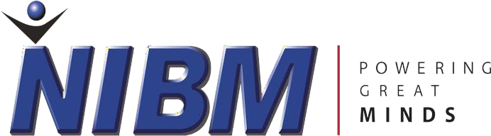

**NATIONAL INSTITUTE OF BUSINESS MANAGEMENT**

**KANDY**

**DIPLOMA IN SOFTWARE ENGINEERING 24.2F**

**FINAL PROJECT PROPOSAL**

**HEALTH GUARD AI DETECTION SYSTEM**

**PREPARED BY**

**D.G.C Minidu KADSE24.2F-004**

**W.A.S Soysa KADSE24.2F-002**

**K.M.H.K Bandara KADSE24.2F-049**

**Ravidu Wickramasinghe KADSE24.2F-041**

**PREPARED FOR**

**Mrs. Inoka Abeysinghe (course-director)**

**DATE OF SUBMISSION**

**03rd of JUNE-2025**

**TABLE OF CONTENTS**

**Chapter 1 : Introduction**

**1.1 Introduction of the Organization…………………………………. 5**

**1.2 Organization Structure……………………………………………. 6**

* 1. **Current Operations in Organization……………………………... 9**

**1.4 Users and Responsibilities Organization………………………… 9**

**1.5 Problem Definition……………………………………………….... 10**

**1.6 Project Objectives…………………………………………………. 10**

**1.7 Proposed Solutions………………………………………………… 11**

**Chapter 2 : Methodology**

**2.1 Introduction……………………………………………………….. 11**

**2.2 Data Collection Method…………………………………………... 11**

**2.3 Software Process Models…………………………………………. 12**

**2.4 Software Development Tools…………………………………….. 13**

**2.5 Testing Strategies…………………………………………………. 14**

**Executive Summary**

**Brief Overview of the Project**

**Health is a vital Sector that has uprisen with modern trends and more evaluating demands in the recent Society. Using Technology has enhanced to make subtle changes in the field of Health Sector in Sri Lanka at the modern Status. This Project aims to address the usage of concepts like machine-Learning based prediction System that will assess the potential threats based on the user input data, including the blood Pressure, Blood Oxygen Level, and Heart-Rate. By alternatively using a Logistic Regression model, the System provides a simple yet effective method to classify the individuals as “Healthy” or “ At Risk” , users can get the insights related to the health status on time to adapt for the proper Precautions.**

**Problem Statement**

**Many individuals who are using the Health Services lacks the immediate access to the medical assessments, leading to a delayed detection of the potential High health risks. Without the timely intervention, conditions such as hypertension, hyperoxia, or abnormal Heart rates can go unnoticed, increasing the risk of severe health complications. There is growing a need to diagnose chronic Health conditions like cardiovascular and respiratory diseases that goes quite unnoticed within the modern days. The Traditional Health checkups require the in-person assessments and it is not quality controlled and assured within the modern sophisticated Society. So, there is a need for an AI-driven Solution to analyze the vital Health Parameters and provide the instant risk assessments, enabling preventive healthcare and timely interventions.**

**2. Machine Learning Model**

* **Logistic Regression (baseline model).**
* **Usage of Advanced models for Experimentation.**
* **Including Feature Engineering Processors like age, BMI, cholesterol levels and Life Factors on Consideration.**

**3. System Architecture**

* **Front-End.**
* **Back-End API.**
* **Database.**
* **Security.**

**4. Deployment & Integration.**

* **Cloud Hosting.**
* **API Development.**
* **Real-time Alerts.**

**Expected Outcomes**

* **A Functional AI-Driven health assessment tool accessible via web and mobilizable applications.**
* **Improved accuracy in Health risk prediction through continuous Learning process.**
* **Seamless Integration with wearables and hospital databases for the real-time Data Collection Process.**
* **Deployment of a scalable and secure system for a broader health-Care Application.**

**Future Enhancements**

* **Expand to multi-class classification for detecting specific health conditions.**
* **Develop a full-scale mobile health app with personalized insights.**
* **Implement real-time monitoring for devices for Hospitals and clinics using IOT – enabled devices.**

**Chapter 1 : Introduction**

**1.1 Introduction of the Organization**

**Liberty Channel Center is an innovative Health Care unit within the Suburbs of Thalawakelle in the Nuwara Eliya District. This Health-Care Unit Comprises with an O.P.D Unit, Pharmacy & Medical Laboratory Services, E.C.G., Dental, X-Ray, Optical & Other Medical Professionals like Consultant Medical V.O.G’s, Consultant Pediatricians attend to this Health Care unit to provide Services to the General Public. This Organization aims in providing Health care services by integrating with the AI-driven Health monitoring into its operations to enhance the patient care and reduce emergency hospital visits. Usage of Digital Technologies is in the foremost consideration within this organization.**

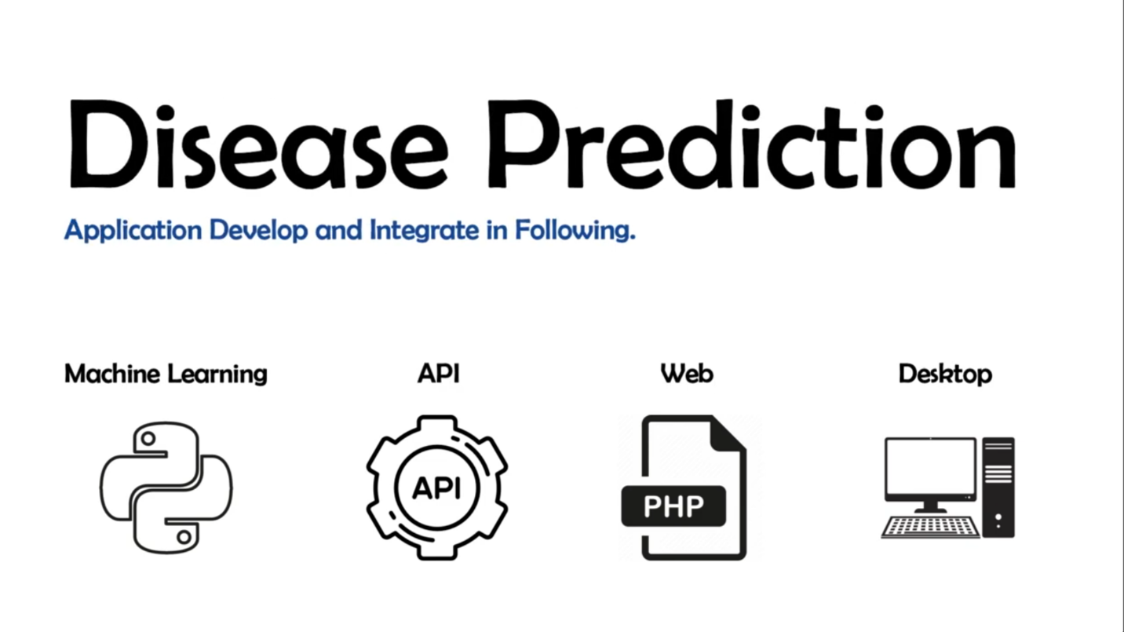

**1.2 Structure of the Organization**

**UML-Diagram**

**1.2 Structure of the Organization**

**UML- Diagram**

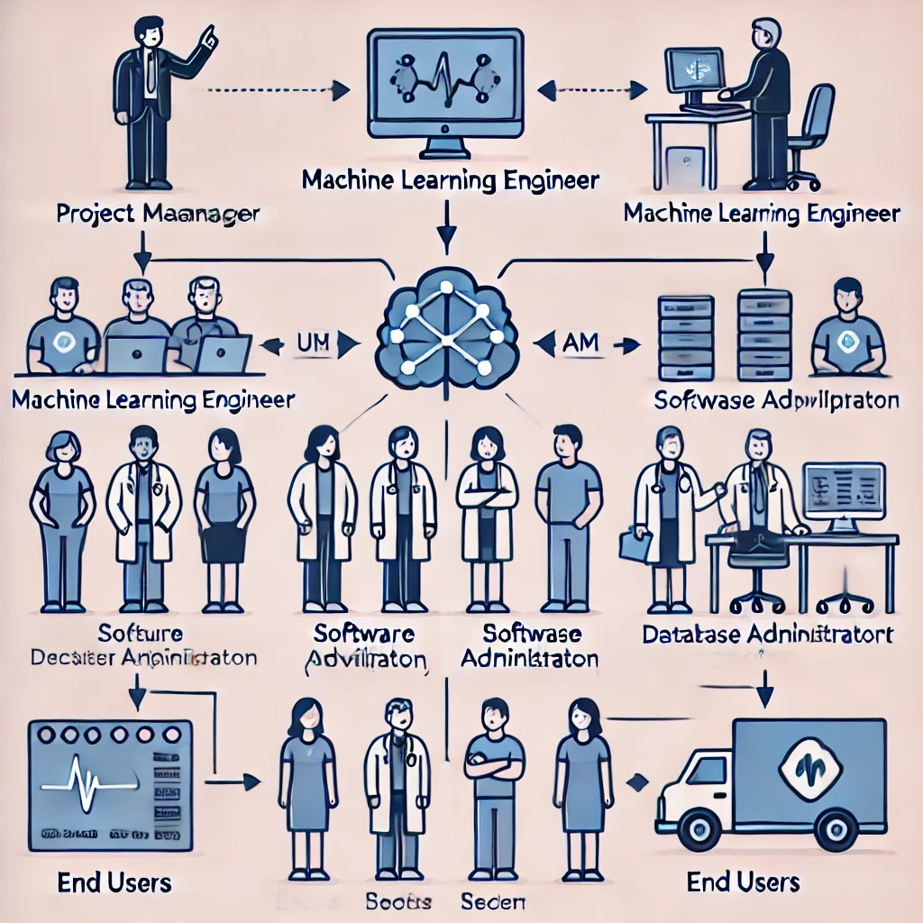

**End Users**

**Medical Professionals**

**End Users**

**Database Administrator**

**Software Administration**

**Medical Administration**

**Software Declaration Administration**

**Software Application**

**Machine Learning Engineer**

**Machine Learning Engineer**

**Machine Learning Database**

**Project - Manager**

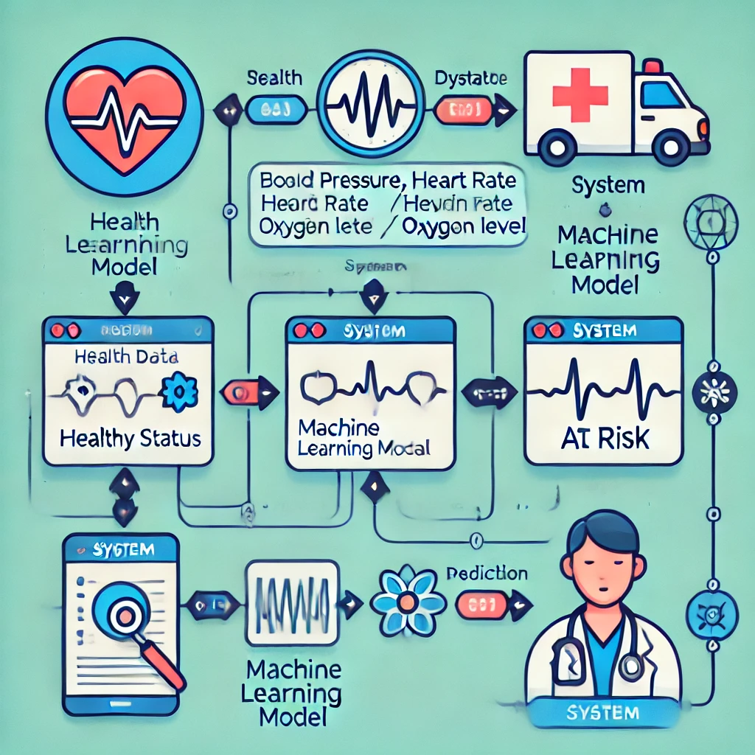

**Prediction**

**At Risk**

**Machine Learning Model**

**Health Learning Model**

**Machine Learning Model**

**Healthy Status**

**Machine Learning Model**

**Blood Pressure, Heart Rate**

**Oxygen Level**

**UML Sequence Diagram**

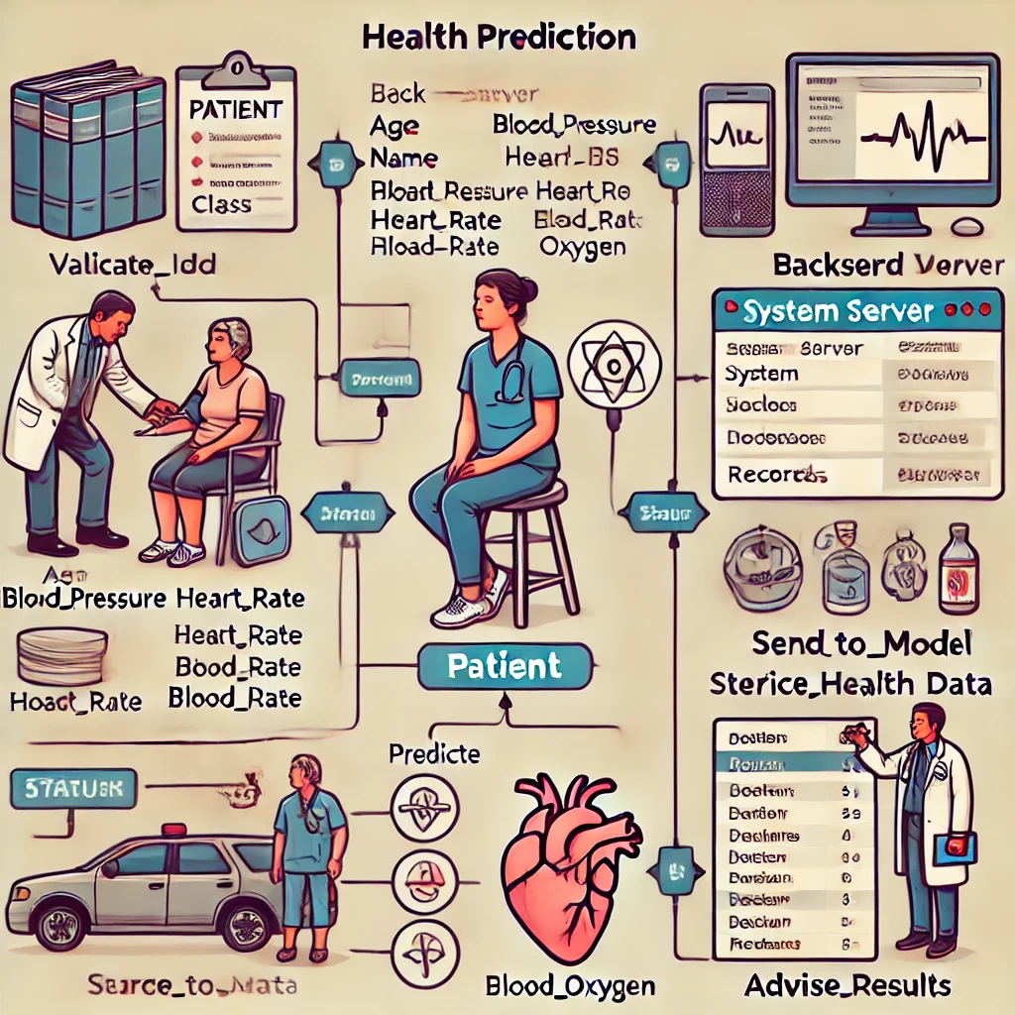

**Service Data**

**Advise Results**

**Predict**

**Validate-IDD**

**Back-end Server**

**Age Blood-Pressure**

**Name Heart_BS**

**Blood Pressure Heartrate**

**Heartrate Blood Rate**

**Bload_Rate Oxygen**

**Health Prediction**

**UML Class Diagram**

**1.3 Current Operations in Organization**

**Currently the Liberty Channel Center relies on manual methods to patient checkups and the electronic health records are to track the patient vitals are kept track on a PC. However, there is no real time monitoring for the process, instead risks are determined by the historical patient data rather than the provocative patient data analysis. This leads to delayed diagnosis in the diseases and limited preventive care interventions. Since the Majority of the People in the Talawakelle are Indian Tamils who are workers of neighboring tea estates, they frequently access the medical services from this Health-Care Unit. Provision of Medical Records are high for this type of Medical Health Care Unit so Machine learning records can be easily retrieved.**

**1.4 Users and Responsibilities Organization**

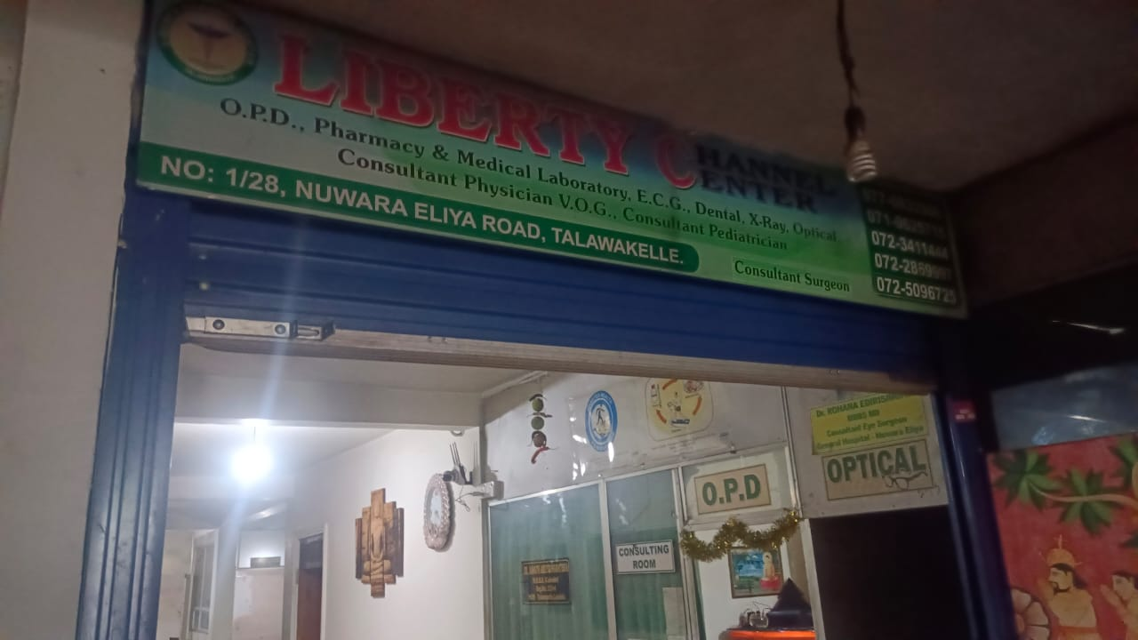 **Healthcare professionals currently rely on periodic checkups and patient-reported symptoms, which can result in missed early warning signs of health deterioration. Liberty Channel Center relies on Doctors, Consultant Physician V.O.G’s , Consultant Pediatricians and well-trained nurses. It’s an immense Challenge to cope up with the vast arrival of patients to this Healthcare unit and to keep track of the records is also an immense challenge.**

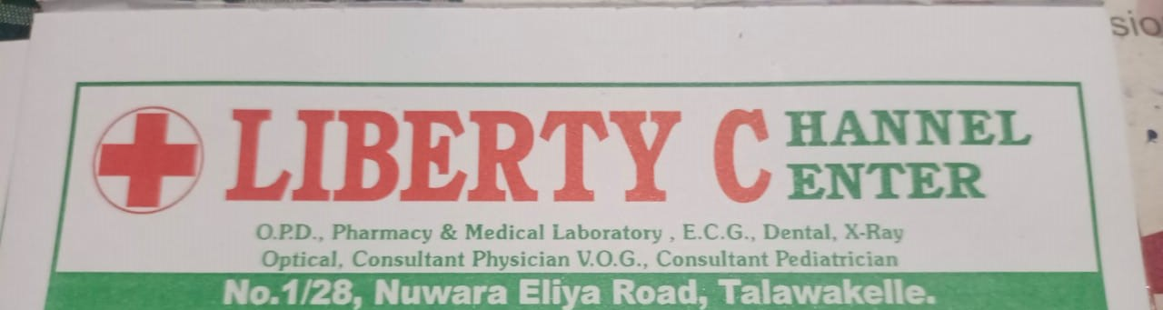

**1.5** **Problem Definition**

**The lack of real-time health monitoring and risk prediction tools in Healthcare Systems in Sri Lanka has led to increased emergency hospital admissions due to preventable health conditions. Without an AI-based solution, patients and doctors rely on reactive rather than proactive healthcare interventions.**

**1.6 Project Objectives**

* **Development of a machine learning model to predict the health risks.**
* **Creating a user-friendly web or mobile application for data input and results visualization.**
* **Integration of wearable devices (smart-watches) for real-time health tracking.**
* **Deploying the system online for easy accessibility and for remote health monitoring purposes.**

**1.7 Proposed Solutions**

**The proposed AI-based health prediction system will leverage machine learning to analyze patient vitals and predict potential health risks in real time. The system will allow users to input data manually via a web/mobile app or automatically sync data from wearables. Predictions will be displayed on a user-friendly dashboard, providing instant insights to both patients and healthcare providers. The model will continuously improve as more patient data is collected, enhancing accuracy over time. Since this Medical Health Care Unit is located in Talawakelle most patients are being the tea-estate workers they visit this unit to get accurate medical services for their illnesses. Language barrier is present for most of the patients those who attend to this Health Care Unit So provision of a machine learning model to submit their medical records in their native language and the usage of AI will make the service provided for them more efficient.**

**Chapter 2 : Methodology**

**2.1 Introduction**

**This chapter outlines the methodologies that we used in designing and implementing the health prediction system. It describes the approach taken for data collection, software development, testing strategies, and project planning. The methodologies ensure the system's accuracy, security, and usability while maintaining compliance with medical data regulations the System.**

**2.2 Data Collection Methods**

**To develop an accurate health prediction system, data is collected from multiple sources:**

**A. Manual Data Entry (Basic Approach)**

* **Patients manually enter their blood pressure, heart rate, and blood oxygen level through a web or mobile application.**
* **Data is stored in a secure database and processed by the ML model for prediction.**

**B. Wearable Devices & IoT Sensors (Advanced Approach)**

* **The system integrates with wearable devices (e.g., Apple Watch, Samsung Galaxy Watch) to collect real-time data.**
* **APIs such as Google Fit, Apple HealthKit, and Fitbit API fetch heart rate, oxygen levels, and activity metrics automatically.**

**C. Hospital & Clinic Databases (Professional Use)**

* **Electronic Health Records (EHRs) from hospitals provide historical patient data.**

**2.3 Software Process Model**

**The Agile Software Development Model is adopted due to its flexibility and iterative nature. The project follows Scrum methodology, which includes:**

* **Sprint Planning: Define development tasks and set sprint goals.**
* **Incremental Development: Regular releases of system features in small, manageable iterations.**
* **Frequent Testing: Continuous evaluation to ensure functionality and performance.**
* **User Feedback Integration: Adjustments based on feedback from healthcare providers and patients.**

**Phases of Agile Development**

* **Requirement Analysis: Identify system functionalities and user needs.**
* **Design & Development: Develop the ML model, backend, and frontend.**
* **Testing & Validation: Evaluate system performance and prediction accuracy.**
* **Deployment & Maintenance: Deploy the system to a cloud server with ongoing updates.**

**2.4 Software Development Tools**

**Programming Languages**

* ✅ **Python** – Core language for machine learning.
* ✅ **PHP** – Backend development for handling web services and database operations.

**Development Environments**

* ✅ **Visual Studio Code** – Lightweight code editor suitable for Python, PHP, and JavaScript.
* ✅ **Visual Studio** – Ideal for developing enterprise applications, especially with **.NET**.
* ✅ **Google Colab** – Cloud-based Jupiter Notebook for quick ML experiments.

**Machine Learning Libraries**

* ✅ **scikit-learn** – Essential for building ML models like Logistic Regression.
* ✅ **TensorFlow / PyTorch** – Advanced deep learning frameworks.
* ✅ **XGBoost / LightGBM** – High-performance gradient boosting frameworks.

**Web Development Frameworks**

* ✅ **Laravel** – PHP framework for backend API and database management.
* ✅ **Django** – Alternative Python framework with built-in security.
* ✅ **React.js** – Frontend UI framework for web applications.

**Database & Security**

* ✅ **PostgreSQL / MySQL** – Secure relational databases for storing patient data.
* ✅ **OAuth / JWT Authentication** – Secure authentication methods for API access.

**Wearable & Health API Integration**

* ✅ **Google Fit API / Apple HealthKit** – Real-time health data collection.
* ✅ **Samsung Health API** – Integration with Samsung smartwatches.
* ✅ **FHIR API / HL7 Protocols** – Standardized health data exchange.

**Deployment & Cloud Hosting**

* ✅ **Docker** – Containerization for deployment.
* ✅ **AWS / Azure / Google Cloud** – Cloud-based hosting solutions.
* ✅ **Kubernetes** – Scalable container orchestration for server-side operations.

**2.5 Testing Strategies**

**To ensure system accuracy, performance, and security, the following testing strategies are applied:**

**A. Unit Testing**

* **Tests individual components such as the ML model, database operations, and API requests using PyTest or Unittest.**

**B. Integration Testing**

* **Ensures proper communication between frontend, backend, and database using tools like Postman and Selenium.**

**C. Performance Testing**

* **Evaluates system speed and load handling using JMeter and Locust.**

**D. Security Testing**

* **Ensures data privacy by testing against SQL Injection, Cross-Site Scripting (XSS), and API vulnerabilities using OWASP ZAP.**

**E. Machine Learning Model Evaluation**

* **Model accuracy is tested using classification metrics like precision, recall, F1-score, and ROC-AUC curve.**